Evidence of local adaptation in temperature tolerance traits of the gametophytic and sporophytic stages in *Solanum carolinense* (horsenettle)

# Emma K. Chandler, Department of Biological Sciences, Dept. 2715, North Dakota State University, PO Box 6050, Fargo, ND 58108-6050, ORCiD: 0000-0002-6507-1091

Steven E. Travers (Corresponding author), Department of Biological Sciences, Dept. 2715, North Dakota State University, PO Box 6050, Fargo, ND 58108-6050, steven.travers@ndsu.edu, ORCiD: 0000-0001-5679-8064

**Keywords:** Local Adaptation; Temperature Tolerance; Solanum carolinense; Gametophytic Selection; Pollen Germination; Plants; Climate Change

Summary

Climate change is rapidly altering local temperature regimes and in different ways across the landscape. To cope with these rapid changes, plant species must have the capacity to respond to changes in temperature stress or risk extinction. We compared temperature tolerance traits in *Solanum carolinense* populations from Texas and Minnesota to understand how a species adapts to extreme temperature stress. We included traits in both the gametophytic and sporophytic stages to differentiate between these distinct phases of selection and determine whether there is a correlation between the two. We found that temperature sensitivity differed between populations of the south that face extreme heat regularly and northern populations that do not. However, the results were not always consistent with our expectations, including counter-gradient results in both the sporophyte and gametophyte. Based on the ideas from previous work, our results support the adaptation of a potential avoidance mechanism to mitigate extreme heat in the gametophyte through producing a higher proportion of pollen grains that remain dormant during high temperature conditions. There were no correlations in temperature tolerance between the sporophyte and gametophyte, suggesting that there are different temperature tolerance strategies between the stages. These findings indicate that wild populations have the potential to adapt to rising temperatures due to climate change in the future.

Introduction

Climate change is rapidly altering environmental conditions at the local level and in particular, temperature and precipitation regimes and the severity of weather events. How will plants, a mostly sessile taxonomic group, cope with these rapid changes? With the uprise of novel local conditions, there are three ways plants can respond while avoiding extinction; quickly adapt, tolerate changing conditions through plasticity in phenotype that allows acclimation to the new conditions, or shift ranges (Janzen, 1967; Schlichting, 1986; Molina-Montenegro & Naya, 2012). We conducted a study that focuses on the variation within populations and addresses the potential for the first two of these options in a widespread, weedy species.

The conditions across a species’ range are almost always heterogeneous and can have a variety of selective pressures that act on the populations differently. (Kawecki & Ebert, 2004)Divergent selection in two locations can result in differing trait optima in the separate populations, leading to local adaptation (Kawecki & Ebert, 2004). Selection is further complicated in angiosperms, in that selection can act independently in the two life stages: the sporophyte (diploid; full plants, vegetation) and the gametophyte (haploid; ovules, pollen). It has been shown that there is a substantial overlap in genes and gene expression between the two stages (Tanksley *et al.*, 1981a; Willing & Mascarenhas, 1984; Pedersen *et al.*, 1987; Beaudry *et al.*, 2020). Previous studies have found correlations between the gametophytic and sporophytic stages in temperature tolerance traits (Hedhly *et al.*, 2005; Poudyal *et al.*, 2019), but these results weren’t consistent across all studies (Dominguez *et al.*, 2005). We seek to resolve inconsistencies in the literature by examining responses to extreme cold and heat in both the sporophyte and gametophyte. Understanding how temperature tolerance adaptation is influenced by selection in each life stage could provide insight into the speed of evolutionary responses.

(Zhu *et al.*, 2018)(Valitova *et al.*, 2019)(Dufourc, 2008a; Dufourc, 2008b; Valitova *et al.*, 2019)(Knight & Ackerly, 2001; Zhu *et al.*, 2018)(Bauwe *et al.*, 2010; Zhu *et al.*, 2018)(Bauwe *et al.*, 2010)(Zhu *et al.*, 2018)(Wahid, 2007; Wahid *et al.*, 2007; Mishra *et al.*, 2019)(Kariola *et al.*, 2005)(Kakani *et al.*, 2002; Singh *et al.*, 2008; Gajanayake *et al.*, 2011)(Zhu *et al.*, 2018)(Dufourc, 2008a; Dufourc, 2008b; Valitova *et al.*, 2019)(Knight & Ackerly, 2001; Rhoads *et al.*, 2005; Frank *et al.*, 2009; Goswami *et al.*, 2010; Liu *et al.*, 2016; Lin *et al.*, 2018; Nurminsky *et al.*, 2018)(Tanksley *et al.*, 1981b; Willing & Mascarenhas, 1984; Pedersen *et al.*, 1987; Beaudry *et al.*, 2020)(Hedhly *et al.*, 2005; Poudyal *et al.*, 2019)Temperature is a variable that can determine species distributions and can vary greatly in both severity and consistency with geographic region (Von Büren & Hiltbrunner, 2022). Based on the IPCC Sixth Assessment Report (Seneviratne *et al.*, 2021), temperatures are changing at unprecedented rates throughout the world. Spatial disparities in local conditions and population-level responses can provide a clue to how a species might respond as global warming changes local conditions. Therefore, we seek to answer the question: how do populations of the same species persist in different temperature regimes?

In this study, we compared plants from Minnesota and Texas and estimated temperature tolerance to extreme hot and cold conditions. Since temperature-based selection in the two life stages has the potential for inter-generational adaptations (thermotolerant pollen yields progeny with thermotolerant leaves), we incorporated variables from both the sporophyte and gametophyte. Sporophytic tolerance was measured using leaf measurements (net photosynthesis, chlorophyll content stability, and cell membrane stability) and the gametophytic variables were measured using pollen (pollen germination and pollen tube growth rate).

The first objective was to determine if local thermal conditions have divergently selected for temperature tolerance traits and led to adaptations reflecting regional climate regimes. We hypothesized that if there was divergent selection and local adaptation of temperature tolerance, then the plants in the north would be more tolerant of cold stress and plants from the south would be more tolerant of heat stress. The second objective was to determine if there is a correlation between temperature tolerance in the gametophyte and sporophyte. If temperature stress is similar in both stages and gene expression patterns in the gametophyte and sporophyte overlap, then there is the potential for a positive correlation of temperature tolerance in the two life stages.

Materials and Methods

Species Description

*Solanum carolinense* L.(Solanaceae), commonly known as horsenettle, is a weedy, herbaceous perennial that originated in southeastern North America. *Solanum carolinense* is in the Carolinense clade of the subgroup Leptostemonum characterized by abundant prickles and spines on the calyx of the flowers (Wahlert *et al.*, 2014). Since all other species in this clade are neotropical, this species likely arose through dispersal to North America and independent diversification. Recently, this species has been reported in states across the United States, along both coasts, as far south as Texas and Florida and as far north as Minnesota and Idaho (Figure 1). *Solanum carolinense* reproduces both sexually and asexually. Asexually, this species utilizes clonal recruitment by growth from rhizomes. This species is buzz-pollinated, meaning that a certain frequency of vibration must be applied to the anthers for pollen to release. The primary pollinators for this species are bumble bees. Once ovules are fertilized, a small, round, green to yellow tomato-like fruit develops on a truss and is dispersed by small mammals, such as skunks, and birds (Cipollini & Levey, 1997).

Plant Collection

*Solanum carolinense* plants from three populations in Texas and two populations in Minnesota were collected between October 2019 and August 2020 (Figure 1). The three southern populations were from Collin County, Texas near McKinney (Oil Patch: 33.173465 N, -96.615402 W; Reserve: 33.159962 N, -96.619011 W; and Cemetery: 33.173672 N, -96.615096 W). At the time of collection, each population consisted of between 10 and 50 mature plants. The Reserve population was located approximately 1.5 km from the Oil Patch and Cemetery populations which were adjacent to each other. The two populations from the north were from Houston County, Minnesota and from here on will be referred to as plants from the northern region or Prairie Island (44.07959 N, -91.684545 W) and Frontenac (44.523056 N, -92.338611 W). These populations are separated by approximately 80 Km (Figure 3). In Colin County TX, the average monthly low temperature is 18°C (65°F) and the average monthly high is 43°C (111°F). In Houston County, MN, the average monthly low temperature is -14°C (7°F) and the average monthly high is 29°C (85°F).

Collections involved digging up and cutting rhizomes of at least 10 cm in length and placing them in ziplock bags. Rhizomes were stored in a cooler with blue ice and shipped to Fargo, ND, where the collections were stored in a 4°C refrigerator. The rhizomes were potted in one-gallon containers with a standard potting mix and grown throughout the summer of 2020. In October, all above ground matter was cut and the rhizomes were again stored in a 4°C refrigerator to induce a period of dormancy.

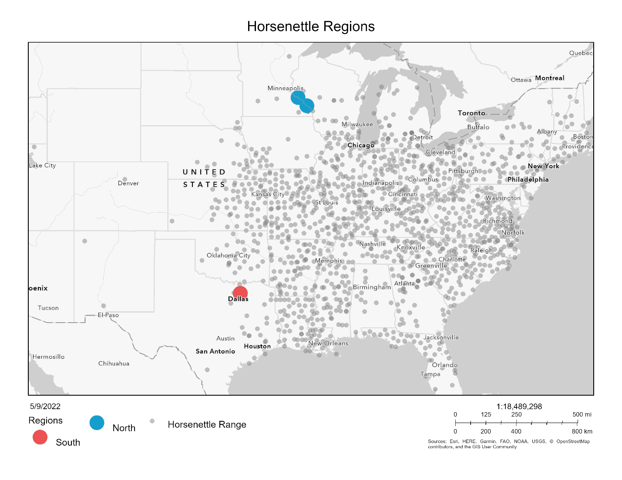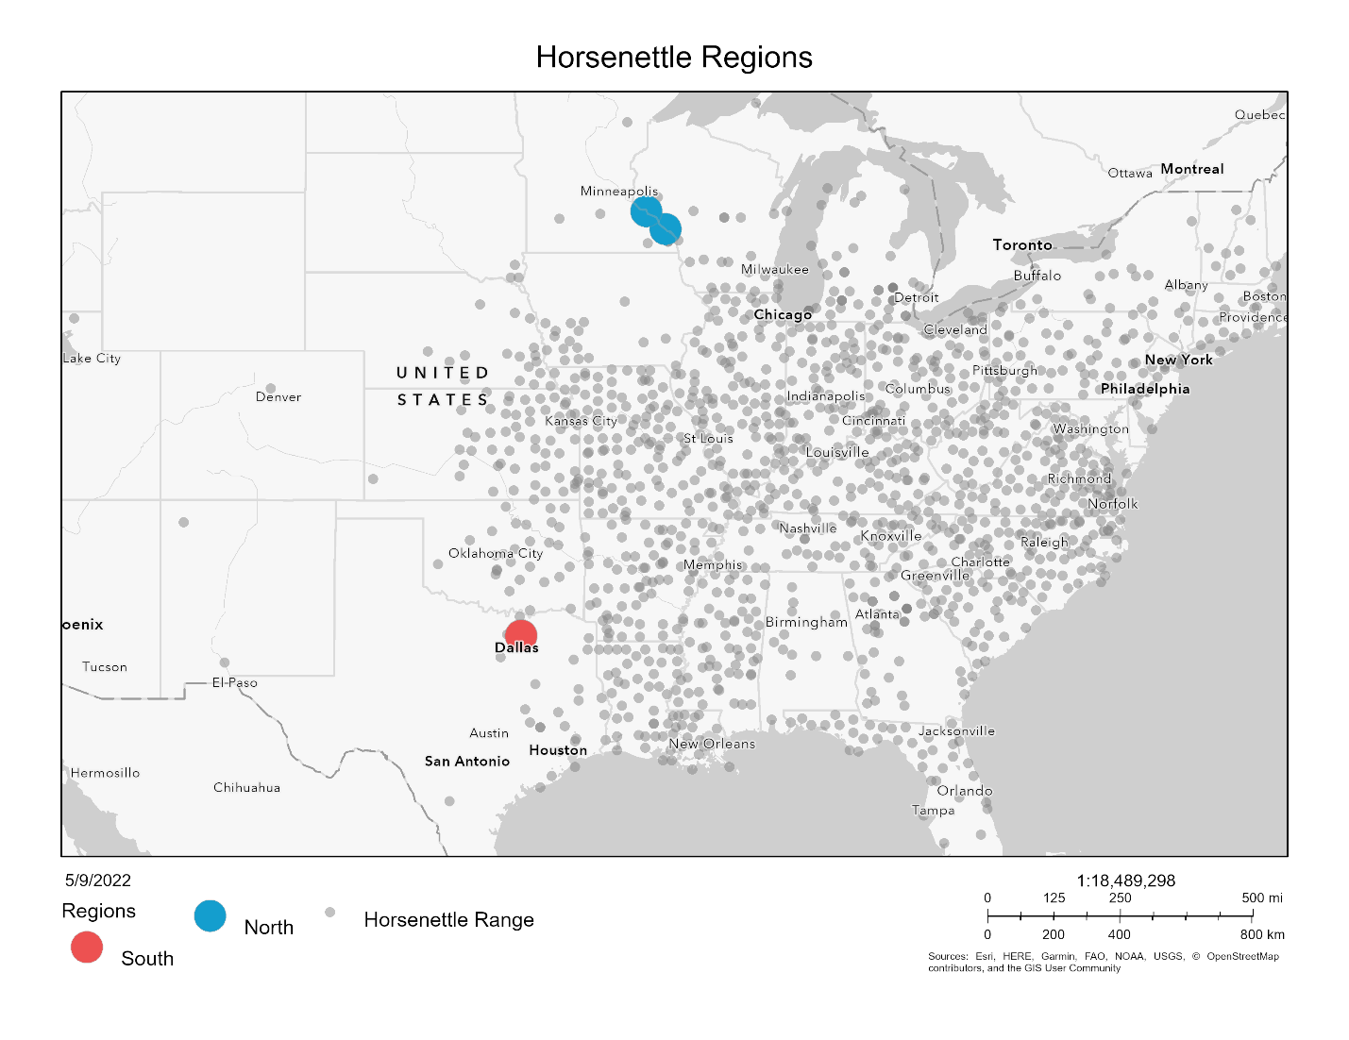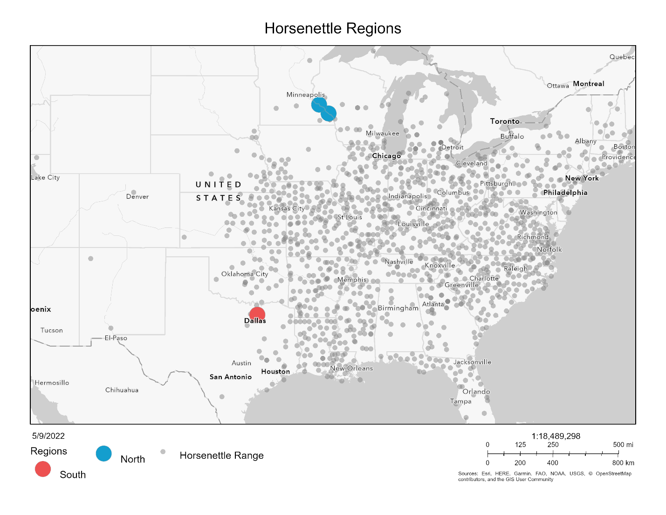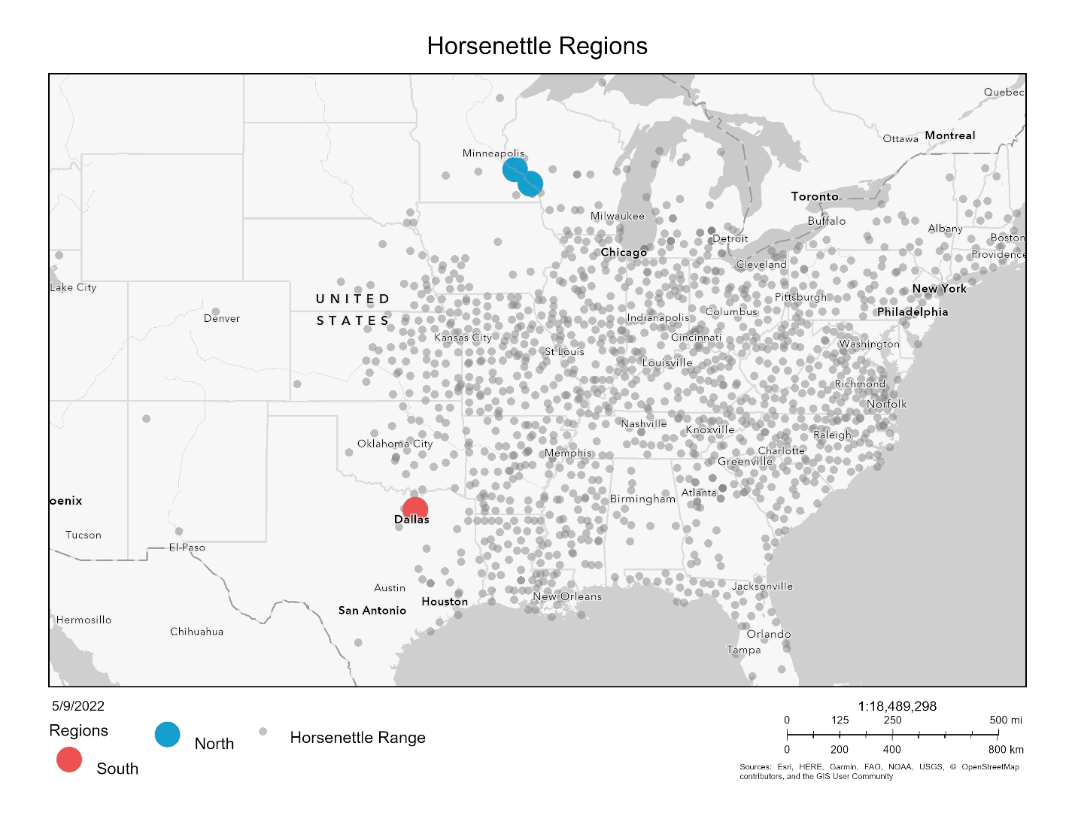

Figure 1. Map with collection sites. Northern sites in blue and southern sites in red. Grey points indicate sites where *Solanum carolinense* was observed (EDDMapS, 2022).

Greenhouse Experiment

After the dormancy period (3 months), equal sections of rhizome (at least 2 cm for thick rhizomes and increased lengths for thinner rhizomes) were cut to grow ramets (genetically identical copies) in 3.8 cm diameter cone-shaped containers in the greenhouse. In total, four ramets (blocks A, B, C, and D) were grown from each genet at separate times. We started 10 or 12 ramets each week (sub-block 1-20), randomly selected from the 52 genets. Of the ramets planted each week, half were from the southern region and half were from the northern region. All ramets in block A were planted over five weeks prior to the planting of the ramets in block B and so on. Northern plants were paired with a southern plant and these pairs were randomly located on greenhouse benches. The plants were fertilized every other week with 10-10-10 fertilizer and transplanted to larger, 4.5 L containers when they outgrew the small cone-shaped containers. After approximately 10 weeks, we began collecting sporophytic measurements from one sub-block per week. Gametophytic data were measured when plants began flowering.

Sporophytic Traits

Cell Membrane Stability

In order to estimate tolerance of leaves to both heat and cold, we examined the cellular stability of leaf material when exposed to relatively high and low temperatures. We used a handheld conductivity meter to measure cell membrane stability (CMS) of leaves after a temperature treatment following the protocol of Gajanayake et al. (2011) and Fang and To (2016). Two large, intact leaves were removed from the middle of a plant and rinsed with deionized water. One leaf was used for the high temperature treatment and the second leaf was used for the cold temperature treatment. Twenty rounds per leaf were punched from each leaf with a hole puncher. Ten of the 20 leaf rounds were placed in a test tube for each temperature treatment (high or low) and 10 were placed in a test tube for a control treatment.

Prior to the high temperature treatment, 10 mL of deionized water was added to the control and temperature treatment test tubes. The high temperature treatment test tubes were placed in a water bath at 55°C for 20 minutes, while the control test tubes were left at room temperature. After exposure to heat, the heat treatment tube was moved to room temperature for 10 minutes prior to the first conductivity measurement.

The low temperature treatment test tubes were placed without water at 10°C for 24 hours followed by 24 hours at 4°C to acclimate the leaf rounds to cooler temperatures. The treatment tubes were then placed at -18°C for 1 hour. The control treatment tubes remained at room temperature for the total 49 hours. After the temperature treatment, 10 mL of deionized water were added to all tubes for both the treatment and control. The tubes were placed at room temperature for 1 hour prior to the first conductivity measurement.

All tubes were then subjected to a maximum damage treatment after the first conductivity measurements to quantify maximum conductivity for each sample. All test tubes were placed in a water bath at 98°C for 1 hour and then left to cool at room temperature for 15 minutes before the second conductivity measurement.

The cell membrane stability value (CMS) used for data analysis was calculated as one minus the proportion of treatment final conductivity to treatment group maximum conductivity divided by one minus the proportion of control final conductivity to control group maximum conductivity. Thus, larger values correspond with higher tolerance to temperature stress (Gajanayake *et al.*, 2011).

$$CMS= \frac{{{1-(Treatment}_{value}}/{{Treatment}_{max})}}{1-({{Control}_{value}}/{{Control}_{max})}}$$

Chlorophyll Content Stability

Mishra et al. (2011) reported on the use of chlorophyll fluorescence as a measure of cold tolerance and Wahid et al. (2007) discussed the correlation between chlorophyll fluorescence and heat tolerance. We were interested in both cold and heat tolerance in this study. We used a chlorophyll meter (Opti-Sciences CCM-300) to measure chlorophyll content. The chlorophyll meter measures the fluorescence emitted at 735nm/700nm for a constant leaf area and uses a ratio based on experiments by Gittelson et al. (1998) to measure chlorophyll content in mg/m2. Two intact leaves were removed from the middle of the plant. One leaf was used for the heat treatment and the other was used for the cold treatment. Each leaf was cut in half and placed in a labeled petri dish. One half was placed in the treatment temperature and the other half was placed in a control setting at room temperature. The chlorophyll content was measured for both halves before and after the temperature treatment.

The high temperature treatment was 60°C for 1 hour. The leaf halves in the cold treatment were subjected to 4°C for 1 hour followed by 1 hour in -18°C. The leaf halves were moved to room temperature for two hours prior to the second cold treatment measurement. Leaves in all treatments were kept in complete darkness.

To control for initial variation in chlorophyll among individuals, we quantified chlorophyll content stability by incorporating the initial and final measurements for both the treatment and control into one value. The chlorophyll content stability ratio (CHPL) was calculated as the compliment of the difference between the proportions of the final treatment chlorophyll content to the initial treatment chlorophyll content and final control chlorophyll content to initial control chlorophyll content. Thus, larger values correspond with higher temperature tolerance (citation).

$$CHPL= 1-\left(\frac{{Control}_{final}}{{Control}_{initial}}- \frac{{Treatment}_{final}}{{Treatment}_{initial}}\right)$$

Photosynthesis

We used a LI-6400 infrared gas analyzer with a red/blue light source to measure net photosynthetic rate (µmol CO2m-2s-1) on leaves before and after the whole plant was exposed to the temperature treatment. The following settings were used for photosynthesis measurements: flow rate 500 μmol s-1, reference CO2 420 μmol CO2 mol-1, reference H2O 0 mmol H2O mol-1, ParIn_μml 400 μmol m-2 s-1.

The high temperature treatment was 33°C and the low temperature treatment was 10°C. All four ramets, if alive, for the 52 genets were subjected to both treatments with a rest period of one week between them. The proportion of the photosynthetic rate measurement after the treatment to before was calculated as our measure of photosynthetic temperature tolerance (PS). Any ratio value below zero and above one was omitted prior to analysis.

$$PS= \frac{{Net Photosynthetic rate}_{final}}{{Net Photosynthetic rate}_{initial}}$$

Gametophytic Traits

We measured two pollen traits as estimates of male thermotolerance during the gametophytic stage: 1) the propensity for pollen grains to germinate (pollen germination) and 2) the growth rate of pollen tubes while exposed to a range of temperatures. Once a plant from the north and from the south flowered, we removed a mature flower from both plants. Pollen from each flower was dispersed over five petri dishes containing 3% Bacto-Agar based growth medium (sucrose, Ca(NO3)2, MgSO4, KNO3, H3BO3) following the protocol of Reddy and Kakani (2007). The dusted plates were each placed at one of the five temperature treatments (10°C, 20°C, 25°C, 30°C, 40°C) for 16 hours in a refrigerator (10°C), Conviron E7/2 environmental chamber (20°C), or three drying ovens (25°C, 30°C, 40°C). After the temperature treatments, each plate was covered with a thin layer of ethanol to halt further pollen tube growth and stored at 4°C until data collection could begin. Four pictures of each plate were taken using a microscope (Leica DM500 microscope, Leica ICC50 HD camera) and the LAS EZ 2.1.0 software.

Pollen germination (Germ) was measured by counting the number of pollen grains that produced pollen tubes and dividing that by the total number of pollen grains observed. All pollen grains in an image were counted until at least 100 pollen grains were observed. Pollen was considered germinated if it produced a tube that was at least half the diameter of the pollen grain. We used the percent of pollen grains with tubes out of the total number of pollen grains as our measure of pollen germination.

(Schneider *et al.*, 2012)Pollen tube growth rate (PTGR) was determined by first measuring the 10 longest pollen tubes in each of the 4 images using the software ImageJ (Schneider *et al.*, 2012). The actual length of each tube was calculated by tracing the length of each tube, calculating length in pixels, and then calibrating each measurement with a stage micrometer. We calculated the mean of the 20 longest tubes out of the 40 measured per plate and estimated growth rate by dividing the mean length by the time allowed for growth (16 hours).

Data Analysis

All data were analyzed in R 4.1.2 (R Core Team, 2020). In order to measure differences in sporophytic traits between plant origins and among genets, we fit linear mixed effects models using the lmer function from the *lmerTest* package (Kuznetsova *et al.*, 2017). Region (north vs. south) was considered the fixed effect and block (A, B, C, D) and genet nested in population as random effects. We dropped the genet nested in population term for cell membrane stability and both random effects terms for net photosynthetic rate to avoid overfitting the model. Since the genet nested in population term was significant for some variables, we compared population and genets independently. Populations were compared using a linear mixed effects model (*lmerTest*; function lmer) with population as the fixed effect and block as the random effect. We used an analysis of variance model in the *stats* package (R Core Team, 2020), to determine if there were differences between genets for each of the sporophytic variables. Since there was a significant block effect in some of the variables, we compared plants from the north and south within block using a paired t-test (*stats*; function t.test). To determine if variation within the northern and southern regions differed, we used the Bartlett’s test of homogeneity of variance (*stats*; function bartlett.test).

For the gametophytic variables, we fit temperature performance curves to the multiple temperature measurements taken for each plant that flowered using the nls.multstart function in the *rTPC* package (Padfield & O'Sullivan, 2021). Of the 25 temperature performance curves available in the *rTPC* package, the quadratic_2008 and the weibull_1995 models had the lowest AIC values. The weibull_1995 model was eliminated from our analyses because maximum values extracted by the weibull_1995 model were infinite for some of the northern plants. From the quadratic curves of each plant that flowered, we extracted three key values for both pollen germination and pollen tube growth rate: the temperature minimum, temperature optimum, and temperature maximum. We then used the key values in an analysis of variance (*stats*; function aov) to determine if there were differences between region and among genets. One outlier was identified using the Grubbs’ test for outliers, grubbs.test function in the *outliers* package (Komsta, 2011), and subsequently dropped from the analysis.

We used correlation analysis (*stats*; function cor) using Pearson’s method to determine if there were any correlations between sporophytic and gametophytic variables. We conducted correlation analysis for all plants together and then the northern and southern plants separately. The Holm-Bonferroni method (*stats*; function p.adjust) was used to adjust p-values to account for multiple correlations. To incorporate relationships between all the variables and examine amalgamated differences among regions and populations, we conducted principal component analysis (PCA) (*stats*; function prcomp). We first conducted PCA on all the sporophytic variables and all gametophytic variables separately and then all variables collectively. Photosynthetic rate was not included in the collective PCA because of limited sample size. We extracted the eigenvalues for the first three principal components for all three PCAs. The eigenvalues for each principal component were compared for the two regions using t-tests (*stats*; function t.test).

Results

Sporophytic Variables

Cell Membrane Stability

When *Solanum carolinense* plants from the north were compared to the south, we found no significant difference in cell membrane stability following the hot treatment (HCMS), but there was a significant difference in the cold treatment (CCMS; Figure 4, Table 1). Southern plants had significantly higher CCMS values than northern plants. We found a significant difference among genotypes in the hot treatment, but not in the cold treatment (Figure 5, Table 1). For both the hot and cold treatments, there were significant differences between the populations. Population differences mostly followed the regional patterns in CCMS. For HCMS, one population (Oil Patch) from the southern region was less tolerant than all other populations (Appendix Figure A1, Table A1).

Because we could not grow all the experimental plants at the same time due to lack of space, we made the above comparisons among regions and genotypes in five different temporal blocks over the course of the spring and summer. To avoid confounding treatments with temporal effects, plants from different regions were paired with each other within blocks. When we tested for the presence of block effects, we found significant effects for both hot and cold CMS (Figure 6). Plants grown at different times in the greenhouse had different CMS ratios. We started growing the plants in the winter and early spring and outside temperatures gradually rose during that time (Appendix Figure A2). Acclimation to higher temperatures later in the year could account for the block differences observed. To remove block effects, we conducted paired t-tests of northern versus southern plants for each of the variables. When plants from the north and south were compared for HCMS, there was a significant difference between the regions (Figure 6) but only in the first block. In that block, northern plants had a higher HCMS than those from the south. For CCMS, there was a significant difference between regions for blocks B and C (Figure 6). In both cases, southern plants were more tolerant of the cold temperatures than northern plants.

Chlorophyll Content Stability

Chlorophyll content was measured before and after either a heat stress (HCHPL) or cold stress (CCHPL) and the calculated value that incorporates the two measurements was used as a proxy for temperature tolerance. As the CHPL increases, the individual sporophyte is more tolerant of the temperature treatment (Gajanayake *et al.*, 2011). There was a significant difference between plants originating in the north and south for both the hot and cold treatments (Figure 4). Northern plants were more tolerant of both heat and cold than were southern plants regardless of block (Table 1). We found a significant difference among individual genotypes (Figure 5, Table 1) and populations (Appendix Figure A1, Table A1) for the cold treatment, but not for the hot treatment. The two regions also differed in variation for HCHPL. In the hot treatment, northern plants had significantly more variation than southern plants (Bartlett’s test p-value = 1.68E-4; Figure 7).

Net Photosynthetic Rate

We used net photosynthetic rate after thermal stress as a physiological indicator of temperature tolerance. PS is the ratio of net photosynthetic rate after the treatment (heat or cold) divided by net photosynthetic rate before the treatment. Increasing PS indicates increasing temperature tolerance of either hot or cold thermal stress (Poudyal *et al.*, 2019). For both the cold (CPS) and hot (HPS) treatments, there was no significant difference between north and south (Figure 4, Table 1). There were also no significant differences among blocks and genotypes for both the hot and cold treatments. There was a significant difference between populations for CPS (Appendix Figure A1, Table A1).

Table 1. Results from the mixed linear model for the difference in region (north vs south) and the one-way analysis of variance results for the difference between individual genets. Red font color highlights observed outcomes when the result was different from the expected pattern. Asterisk indicates analysis with one outlier removed determined using Grubbs’ test for one outlier. Bolded values represent relationships that were statistically significant. Statistic values reported in the Appendix (Table A2), as well as results from a mixed model using only control values (Appendix Table A3).

|  |  |  |  |  |  |  |
| --- | --- | --- | --- | --- | --- | --- |
|  |  | Region | | | Genet | |
|  | Variable | Expected | Observed | p-value | Observed | p-value |
| Sporophyte | Cell Membrane Stability (Heat) | S > N | - | 0.06102 | **Yes** | **0.013** |
| Cell Membrane Stability (Cold) | N > S | **S > N** | **0.0117** | No | 0.886 |
| Chlorophyll Content (Heat) | S > N | **N > S** | **0.0405** | No | 0.38 |
| Chlorophyll Content (Cold) | N > S | N > S | **9.96E-11** | **Yes** | **1.05E-07** |
| Photosynthetic Rate (Heat) | S > N | - | 0.997 | No | 0.127 |
| Photosynthetic Rate (Cold) | N > S | - | 0.77 | No | 0.883 |
| Gametophyte | Pollen Germination (Tmax) | S > N | **N > S** | **0.00037** | **Yes** | **0.0251** |
| Pollen Germination (Topt) | S > N | **N > S** | **0.000685** | **Yes** | **0.0351** |
| Pollen Germination (Tmin) | S > N | - | 0.331 | **Yes** | **\*0.0135** |
| Pollen Tube Growth Rate (Tmax) | S > N | - | 0.568 | No | 0.418 |
| Pollen Tube Growth Rate (Topt) | S > N | - | 0.77 | No | 0.608 |
| Pollen Tube Growth Rate (Tmin) | S > N | - | 0.683 | No | 0.496 |

Figure 4. Regional differences for temperature tolerance traits including hot and cold cell membrane stability (HCMS, CCMS), hot and cold chlorophyll content stability (HCHPL, CCHPL), hot and cold net photosynthetic rate (HPS, CPS). Center line of boxplot is the median value for the region. Shared letters represent statistically non-significant differences between regions. Variables with significant differences denoted with asterisks: CCMS (F1,50 = 7.792, p = 0.006), HCHPL (F1,51 = 4.334, p = 0.043), and CCHPL (F1,50 = 64.652, p = 1.6e-10).

Figure 5. Genotype differences for temperature tolerance traits including hot cell membrane stability (HCMS) and cold chlorophyll content stability (CCHPL). Genets are ordered by increasing ratio for each variable. The center line in boxplot is the median of the measurements among the ramets of one genet. There is a significant difference among the genets for HCMS (F = 1.5, p = 0.029) and CCHPL (F = 3.341, p = 6.1e-9). Plots of genet effect for other variables are in appendix (Figure A3).

Figure 6. Cell membrane stability across temporally independent blocks and colored by region. The center line of the boxplot is the median of the measurements taken for each region within a ramet. There is a significant difference between blocks for hot cell membrane stability (HCMS, p = 0.0297) and cold cell membrane stability (CCMS, p = 7.30e-05). Asterisks indicate a significant difference between regions from a paired t-test of regions for each block independently. There was a significant difference between regions for HCMS block A (t = -2.910, p = 0.015), CMS block B (t = 2.190, p = 0.040), and CMS block C (t = 2.073, p = 0.049). Results from paired t-tests between blocks for each variable located in the appendix (Table A4).

Figure 7. Hot chlorophyll content (HCHPL) vs cold chlorophyll content (CCHPL) for plants from the north and south. Ellipse indicating 95% confidence interval for multivariate T distribution. Results from Bartlett’s test for heterogeneity of variance between regions for all variables located in the appendix (Table A5).

Gametophytic Traits

Pollen Germination

Of all genets included in this study, 20 from the north flowered and 10 from the south flowered. The number of ramets that flowered for each genet differed, so the total number of plants that flowered were 32 from the north and 29 from the south. We fit quadratic curves (Appendix Figure A4) to temperature performance profiles of each plant for pollen germination at five temperatures (Figure 8). From the quadratic fit, we calculated the minimum (Tmin), maximum (Tmax), and optimal (Topt) temperature of pollen germination for each individual. There was a significant difference between regions for Tmax and Topt (Figure 8, Figure 9). Plants from the north germinated more readily at high temperatures and had higher thermal optima than plants from the south. There was no significant difference between the two regions for Tmin. The genets were significantly different from one another for Tmin, Tmax, and Topt (Figure 10, Appendix Figure A5). One outlier was identified using the Grubbs’ test for outliers and subsequently dropped from the analysis.

Pollen Tube Growth Rate

The pollen tube growth rates for each individual were also fit with a quadratic curve to estimate the Tmin, Tmax, and Topt. There were no significant differences between plants from the north and south for any of the three variables (Appendix Figure A6). There were also no significant differences among genets (Appendix Figure A7, Figure A8).

Figure 8. Percent germination and mean pollen tube growth rate (PTGR) for *Solanum carolinense* pollen grains from the north (blue) and south (red) across a temperature gradient (10°C, 20°C, 25°C, 30°C, 40°C). Thin lines and points represent each individual plant that flowered. Thick lines indicate the mean value for the region at each temperature.

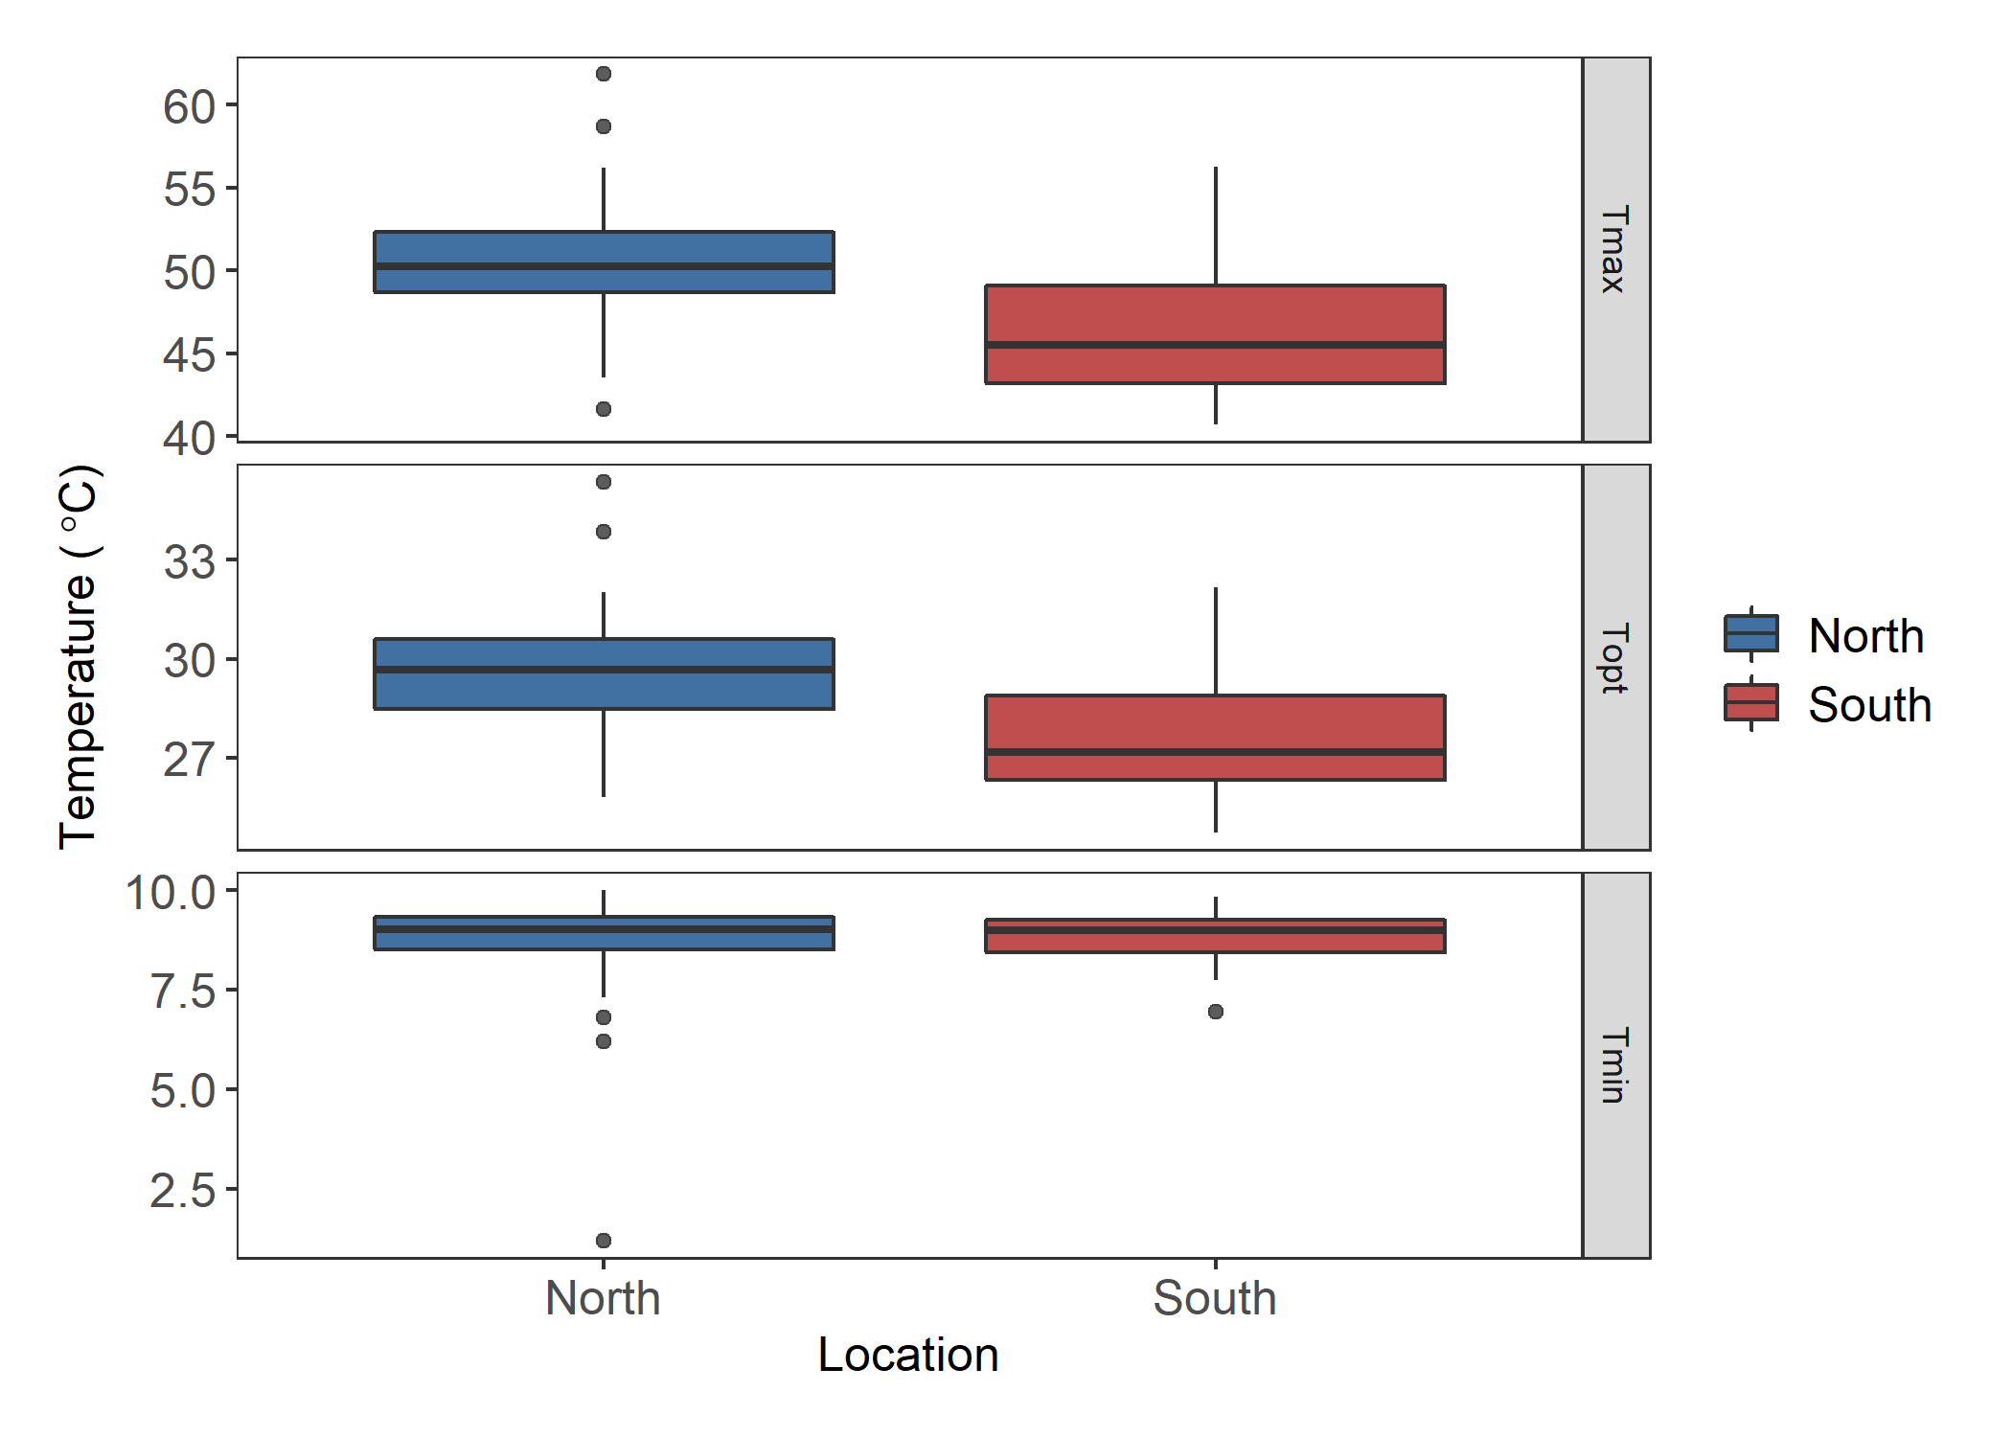

A

B

*

A

B

*

A

A

Figure 9. Estimates for the maximum (Tmax), optimal (Topt), and minimum (Tmin) germination temperature extracted from quadratic fits of the germination data for each individual. Asterisks and different letters indicate significant differences. There was a significant difference between regions for Tmax (F = 14.28, p = 3.7E-4) and Topt (F = 12.85, p = 6.85E-4).

*

Figure 10. Boxplots of the maximum (Tmax), optimal (Topt), and minimum (Tmin) pollen germination temperatures by genet. There was a significant difference between the genets for Tmax (F = 2.064, p = 0.025), Topt (F = 1.952, p = 0.035), and Tmin (F = 2.284, p = 0.0135). Asterisk indicates the outlier removed for analysis.

Correlations

We used correlation analysis to identify relationships between hot and cold tolerance for the sporophytic and gametophytic variables. Pearson’s correlations were determined for all pairings of variables. When all plants were included, there were no significant correlations between the gametophytic and sporophytic variables (Figure 11, Appendix Table A6). However, there were two significant correlation coefficients between gametophytic variables. Maximum and minimum pollen tube growth rate were positively correlated (r = 0.46). Maximum pollen tube growth rate and maximum pollen germination were positively correlated (r = 0.3).

Figure 11. Correlation matrix of all plants. Gametophytic (labels blue font) and sporophytic variables (labels red font) with significant Pearson’s correlations for all study plants.

When the correlation analysis was performed on all variables for the regions separately, there were different results. For the northern plants, there were no significant correlations. The southern plant had one significant correlation between Tmin germination and Tmax germination (r = -0.63; Appendix Figure A9).

Principal Component Analysis

We conducted principal component analysis to further explore relationships among all variables and the sporophytic and gametophytic variables separately. For the full PCA, we included all gametophytic and sporophytic variables, except HPS and CPS due to inadequate sample size. The first three principal components accounted for 57% of the variation (full PCA plots and loadings in the appendix Figure A11, Table A7). There was little divergence between regions. When the eigenvalues of the principal components were compared between regions, PC2 was the only principal component that showed a significant difference (t58 = -2.69, p = 0.0092). Chlorophyll content (HCHPL and CCHPL) loads primarily on PC2 and is likely driving the divergence between northern and southern plants.

Sporophytic PCA

In the sporophytic variables PCA, the first three principal components explained 60% of the variation. The variables HCMS and HPS primarily loaded on PC1 (Table 2, Figure 13). The second and third principal components were mostly influenced by CCHPL and HCHPL respectively. There was a significant difference between the regions for the eigenvalues extracted from both PC2 (t78 = -5.09, p = 2.39e-06) and PC3 (t101 = 2.38, p = 0.019). The divergence in PC2 can be explained by the opposite responses we observed for CCMS and both chlorophyll content treatments. Northern plants have a higher chlorophyll content ratio for both treatments, while southern plants had less cell membrane damage in the cold treatment. PC1 did divide HCMS and CCMS, suggesting an antagonistic relationship between the two variables, though there was no correlation between the two that was statistically significant. Hot and cold treatment variables were also divided in PC3. HPS and HCHPL were opposite in direction to CPS and CCHPL.

Figure 12. Plots of the results of principal component analysis for the sporophytic variables. A) PC1 and PC2, B) PC2 and PC3, C) PC1 and PC3. Ellipsoid indicating 95% confidence interval. PC1 explains 22.38% of the variance, PC2 explains 21.55% of the variance, and PC3 explains 16.79% of the variance. Tables with principal component importance for PC1 through PC6 in the Appendix (Table A8).

Table 2. Results from principal component analysis of only sporophytic variables. Loadings for each of the variables on the principal components

|  |  |  |  |  |  |  |
| --- | --- | --- | --- | --- | --- | --- |
|  | PC1 | PC2 | PC3 | PC4 | PC5 | PC6 |
| HCMS | 0.613999 | 0.02998 | 0.344975 | 0.147492 | 0.573797 | 0.390002 |
| CCMS | -0.35207 | 0.435008 | 0.204072 | -0.57534 | 0.520509 | -0.20789 |
| HCHPL | 0.284794 | -0.36797 | -0.33836 | -0.75803 | -0.08744 | 0.294536 |
| CCHPL | 0.117118 | -0.57752 | 0.579996 | -0.14114 | -0.03843 | -0.5431 |
| HPS | 0.577968 | 0.302596 | -0.40867 | 0.000171 | 0.044159 | -0.63673 |
| CPS | 0.264909 | 0.499375 | 0.470594 | -0.22955 | -0.6235 | 0.13244 |

Gametophytic PCA

In the gametophytic PCA, the first three components explained 92.5% of the variance. Pollen germination variables divided the northern and southern plants (Figure 14). Tmax and Topt loaded evenly in the opposite direction of Tmin for both PC1 and PC2 (Table 3, Figure 14). There was a significant difference between north and south for the eigenvalues extracted from PC2 (t46 = -3.17, p = 0.0025). PTGR variables loaded evenly on the first two principal components, indicated by the common diagonal direction among the PTGR variables (Table 3, Figure 14).

Figure 13. Plot of the results of principal component analysis of the gametophytic variables. PC1 describes 48% of the variation and PC2 explains 27%. A table of importance of principle components 1 through 6 is in the Appendix (Table A9).

Table 3. Results from principal component analysis of only gametophytic variables. Loadings for each of the variables on the principal components

|  |  |  |  |  |  |  |
| --- | --- | --- | --- | --- | --- | --- |
|  | PC1 | PC2 | PC3 | PC4 | PC5 | PC6 |
| Germ.Tmin | -0.01334 | 0.405643 | 0.812217 | 0.376238 | -0.00058 | -0.18446 |
| Germ.Topt | 0.418665 | -0.45436 | 0.390064 | -0.00262 | 0.001723 | 0.682727 |
| Germ.Tmax | 0.407763 | -0.5446 | 0.164764 | -0.10069 | -0.00179 | -0.707 |
| PTGR.Tmin | 0.367661 | 0.452838 | 0.127813 | -0.75119 | -0.28131 | 0.00071 |
| PTGR.Topt | 0.523981 | 0.308129 | -0.20261 | 0.123985 | 0.757676 | -0.00193 |
| PTGR.Tmax | 0.498538 | 0.180049 | -0.3219 | 0.518304 | -0.58888 | 0.001496 |

Discussion

Regional Differences

If *Solanum carolinense* has locally adapted to the respective temperature regimes in TX and MN, we would expect that plants from the north would be more tolerant of cold temperatures and plants from the south would be more tolerant of hot temperatures. In contrast to our expectations, northern plants were generally more tolerant of extreme heat than southern plants, but also had more variation in certain trait values. Northern plants had higher chlorophyll content (HCHPL) and baseline cell membrane stability (HCMS; Figure 6) under hot conditions, as well as higher maximum and optimal temperatures for pollen germination in comparison to southern plants (Table 1). Conversely, southern plants had increased tolerance for cell membrane stability in cold conditions (CCMS). These results suggest that adaptation to extreme temperatures is complex and may reflect avoidance strategies rather than physiological mechanisms to withstand thermal stress.

There was no significant difference between regions for HCMS for all study plants together, but there was a significant difference for plants in block A. Temperatures in the greenhouse progressively rose throughout the spring and summer leading to a block effect in both the hot and cold treatments of CMS. In block A, northern plants had a higher HCMS, but this difference degraded in the later blocks during the times when greenhouse temperatures during plant development increased. The block effect on CMS may be due to S. carolinense’s capacity to induce heat tolerance as they acclimate to warmer conditions (Clarke *et al.*, 2004). Block A is the best representative measurement of baseline heat tolerance for HCMS, and later blocks likely represent induced heat tolerance. This may be more dramatic in southern plants. Conversely, plants from the south had more stable cell membranes when exposed to an extreme cold treatment. This pattern may be due to constraints of adaptation to extreme heat or cold. Adapting to match the extreme environmental conditions may not be advantageous or possible, reducing the variation in a population for tolerance in extreme conditions. Thus, populations in locations that do not experience extreme temperatures on one end of the spectrum may have more variation than those that do experience extreme temperatures, leading to the counter gradient results we attained for CMS.

Plants from the north had more stable chlorophyll content in both the hot (HCHPL) and cold treatments (CCHPL; Table 1). More stable chlorophyll content may be explained by northern plants experiencing a larger range of temperatures. Between 2018 and 2021, temperatures during the growing season (March to September) in Houston County, MN ranged from -28°C to 34°C (62°C difference), while in Collin County, TX they ranged from -7°C to 42°C (49°C difference). Since the temperate conditions of Minnesota are more variable and rarely exceed temperatures likely to stop plant growth (Hatfield *et al.*, 2011), populations in the north may have evolved to acclimate to temperature stress, while plants in the south do not. Furthermore, northern plants also had significantly more variation in HCHPL than southern plants. This may suggest that there is stabilizing selection occurring in the southern region for heat tolerance in chlorophyll content. Less variation in HCHPL in the south may contribute to the counter-gradient results we attained. If northern plants experience less heat stress selection and have greater variation, then there may be more potential to have individuals with high HCHPL.

Pollen from the north had a higher propensity to produce pollen tubes (Germ) at high temperatures than their southern counterparts. Pollen germination was higher in pollen grains from the northern plants than those in the south for both Tmax and Topt (Table 1). The distinct difference between north and south suggests that there might be sensitivity to high temperatures and an adaptive response occurring. Since southern populations experience extremely high temperatures more regularly than northern plants, there may be an avoidance strategy in southern populations whereby pollen grains remain dormant at high temperatures. In contrast, there is no selection for dormancy at high temperatures in the north. Rutley et al. (2022) proposed the two-baskets model categorizing pollen, which states that there are active (high-ROS) and backup (low-ROS) subpopulations of pollen within anthers of flowering species. The low-ROS pollen have a lower metabolic rate than high-ROS pollen due to partial dehydration during development. The two subpopulations of pollen are adaptive and beneficial under different conditions as they allow for asynchrony in pollen germination, permitting some pollen to remain dormant in a stressful environment, such as extreme heat or drought, and grow pollen tubes later in more favorable conditions. Keller and Simm (2018) compared the transcriptome and proteome in *Solanum lycopersicum* (tomato) and determined that pollen have two responses during heat stress – direct and delayed translation and thus growth initiation. Luria et al. (2019) later showed that *Solanum lycopersicum* has pollen that fall in the low-ROS and high-ROS groups, supporting the two-basket model in a species closely related to *Solanum carolinense*. We hypothesize that *Solanum carolinense* populations in the south have higher proportions of low-ROS to high-ROS pollen grains than those in the north due to stronger selection from increased exposure to extreme heat in the south. Low-ROS pollen that remains dormant would not be adaptive in northern populations, with little exposure to high temperature stress.

There was a significant negative correlation between Tmax and Tmin germination in southern plants. This correlation supports the two-basket model. The negative correlation indicates that plants with pollen that germinate readily at high temperatures also germinate at low temperatures, while those that have a lower Tmax have a higher Tmin. High-ROS pollen would germinate in any condition (extreme heat and cold stress). Low-ROS pollen would not germinate as freely during stressful conditions. Since plants of the south may have evolved to have the dual pollen types, there may be more variation in pollen activity driving this correlation.

There was no significant difference between northern and southern plants for net photosynthetic rate in both the hot and cold treatments. Net photosynthesis was the only sporophytic variable where the whole plant was placed in a temperature treatment and leaves were measured on the plant. The plant may compensate for temperature stress through physiological mechanisms, such as increasing transpiration. Therefore, the temperature treatments may not have stressed the plants to the extent that temperature tolerance for the northern and southern plants was distinguishable.

The response of plants from the two regions to extreme cold were considerably more mixed. There was no significant difference between northern and southern populations for Tmin of either pollen germination or pollen tube growth rate. Of all cold traits only two sporophytic traits (CCMS and CCHPL) differed between regions and were not consistent. Pollen may have a low temperature limit on physiological processes necessary for pollen tube growth that are consistent across all populations.

Inter-Generational Relationships

Tanksley et al. (1981a) highlighted the association between selection in the gametophyte and sporophyte when they found a correlation between allozyme genes expressed in both stages. Based on their findings and several studies that followed (Willing & Mascarenhas, 1984; Pedersen *et al.*, 1987; Hedhly *et al.*, 2005; Poudyal *et al.*, 2019), including studies on temperature tolerance (Hedhly *et al.*, 2005; Poudyal *et al.*, 2019), we hypothesized that there would be a correlation between temperature tolerance in the sporophyte and the gametophyte. Correlations between the two life stages have implications for the rate of temperature tolerance evolution. Selection in either stage for similar traits that are expressed independently would rapidly increase or decrease the allele frequency of associated genes in a population. Furthermore, in the gametophyte, there is a lack of dominance allowing selection to act on one allele (Beaudry *et al.*, 2020). The alleles selected for in the gametophyte can then affect traits in the sporophyte.

There were no significant correlations between any of the gametophytic and sporophytic variables in our study, suggesting that there are different mechanisms mitigating temperature stress in the two stages. This is not the first study to find differences in patterns for extreme temperature tolerance in the sporophyte and gametophyte. Dominguez et al. (2005) conducted a study to determine if pollen selection can be used to improve cold tolerance in the gametophyte by selecting pollen from cold tolerant plants (sporophyte). They found that pollen selection did not improve pollen viability and formation in cold and explained their results by describing how the genes mediating cold stress may be expressed in the sporophyte tissue surrounding the site of pollen formation, rather than the pollen grains themselves.

Another explanation for the lack of coordinated response to temperature stress between the two life stages is that horsenettle has not been located in MN and TX long enough for selection to act on the populations. All populations included in this study were located toward the edge of the range for this species. Time for selective pressures to act on the populations may be insufficient for local adaptation to occur. The first record of *Solanum carolinense* in Minnesota is from 1939 and in Houston County 1975 (Bell Museum Plants, Minnesota Biodiversity Atlas; The University of Minnesota). The first record in Texas is from 1917 and the closest record of horsenettle to Collin County is from 2011 (Lundell Herbarium, Billie L. Turner Plant Resources Center; The University of Texas at Austin).

Conclusion

Our results are consistent with a process of local adaptation due to temperature acting as a selective pressure. The results of this study do not completely support our original predictions based on the assumption that northern latitudes are simply cooler than southern latitudes. The measurements of chlorophyll content did provide some evidence that populations from areas with larger thermal ranges, such as those in higher latitudes, have more variation and possibly more phenotypic plasticity, which is consistent with the climate variability hypothesis. The block effects observed in both HCMS and CCMS also suggest that there is plasticity in the phenotype when exposed to long-term changes in ambient temperature. Lastly, we found evidence of southern plants avoiding pollen germination in high temperatures by increasing the proportion of low-ROS to high-ROS pollen.

These results could inform restoration efforts by changing the way we think about seed sourcing and adaptive potential in a rapidly changing environment. Seeds from the south may have evolved stress responses to temperature that are lacking in northern populations or vice versa. The evidence for the two-basket model in a wild species is also a novel finding that could add to our perception of the influence gametophytic traits have on species persistence in extreme environments.

References

**Bauwe H, Hagemann M, Fernie AR. 2010.** Photorespiration: players, partners and origin. *Trends in plant science* **15**(6): 330-336.

**Beaudry FEG, Rifkin JL, Barrett SCH, Wright SI. 2020.** Evolutionary Genomics of Plant Gametophytic Selection. *Plant Communications* **1**(6): 100115-100115.

**Cipollini ML, Levey DJ. 1997.** Why are Some Fruits Toxic? Glycoalkaloids in Solanum and Fruit Choice by Vertebrates. *Ecology (Durham)* **78**(3): 782-798.

**Clarke SM, Mur LAJ, Wood JE, Scott IM. 2004.** Salicylic acid dependent signaling promotes basal thermotolerance but is not essential for acquired thermotolerance in Arabidopsis thaliana. *The Plant journal : for cell and molecular biology* **38**(3): 432-447.

**Connolly BA, Anderson GJ. 2003.** Functional significance of the androecium in staminate and hermaphroditic flowers of Solanum carolinense (Solanaceae). *Plant systematics and evolution* **240**(1/4): 235-243.

**Dominguez E, Cuartero J, Fernandez-Munoz R. 2005.** Breeding tomato for pollen tolerance to low temperatures by gametophytic selection. *Euphytica* **142**(3): 253-263.

**Dufourc EJ. 2008a.** Sterols and membrane dynamics. *Journal of Chemical Biology* **1**(1-4): 63-77.

**Dufourc EJ. 2008b.** The role of phytosterols in plant adaptation to temperature. *Plant Signaling & Behavior* **3**(2): 133-134.

**EDDMapS 2022**. EarlyDetection & Distribution Mapping System: The University of Georgia- Center for Invasive Species and Ecosystem Health.

**Fang J-Y, To NA. 2016.** Heat tolerance evaluation in commercial African violet cultivars using physiological and pollen parameters. *Scientia horticulturae* **204**: 33-40.

**Frank G, Pressman E, Ophir R, Althan L, Shaked R, Freedman M, Shen S, Firon N. 2009.** Transcriptional profiling of maturing tomato (Solanum lycopersicum L.) microspores reveals the involvement of heat shock proteins, ROS scavengers, hormones, and sugars in the heat stress response. *Journal of experimental botany* **60**(13): 3891-3908.

**Gajanayake B, Trader BW, Reddy KR, Harkess RL. 2011.** Screening Ornamental Pepper Cultivars for Temperature Tolerance Using Pollen and Physiological Parameters. *HortScience* **46**(6): 878-884.

**Gitelson AA, Buschmann C, Lichtenthaler HK. 1998.** Leaf chlorophyll fluorescence corrected for re-absorption by means of absorption and reflectance measurements. *Journal of plant physiology.* **152**(2-3): 283.

**Goswami A, Banerjee R, Raha S. 2010.** Mechanisms of plant adaptation/memory in rice seedlings under arsenic and heat stress: expression of heat-shock protein gene HSP70. *AoB plants* **2010**: plq023-plq023.

**Hatfield JL, Boote KJ, Kimball BA, Ziska LH, Izaurralde RC, Ort D, Thomson AM, Wolfe D. 2011.** Climate Impacts on Agriculture: Implications for Crop Production. *Agronomy journal* **103**(2): 351-370.

**Hedhly A, Hormaza JI, Herrero M. 2005.** Influence of genotype-temperature interaction on pollen performance: Variation in pollen performance. *Journal of evolutionary biology* **18**(6): 1494-1502.

**Janzen DH. 1967.** Why Mountain Passes are Higher in the Tropics. *The American naturalist* **101**(919): 233-249.

**Kakani VG, Prasad PVV, Craufurd PQ, Wheeler TR. 2002.** Response of in vitro pollen germination and pollen tube growth of groundnut (Arachis hypogaea L.) genotypes to temperature: Response of groundnut pollen to temperature. *Plant, cell and environment* **25**(12): 1651-1661.

**Kariola T, Brader G, Li J, Palva ET. 2005.** Chlorophyllase 1, a Damage Control Enzyme, Affects the Balance between Defense Pathways in Plants. *The Plant cell* **17**(1): 282-294.

**Kawecki TJ, Ebert D. 2004.** Conceptual issues in local adaptation. *Ecology letters* **7**(12): 1225-1241.

**Keller M, Simm S. 2018.** The coupling of transcriptome and proteome adaptation during development and heat stress response of tomato pollen. *BMC Genomics* **19**(1).

**Knight CA, Ackerly DD. 2001.** Correlated evolution of chloroplast heat shock protein expression in closely related plant species. *American Journal of Botany* **88**(3): 411-418.

**Komsta L 2011**. outliers: Tests for outliers.

**Kuznetsova A, Brockhoff PB, Christensen RHB. 2017.** lmerTest Package: Tests in Linear Mixed Effects Models. *Journal of Statistical Software* **82**(13): 1 - 26.

**Lin J-S, Kuo C-C, Yang IC, Tsai W-A, Shen Y-H, Lin C-C, Liang Y-C, Li Y-C, Kuo Y-W, King Y-C, et al. 2018.** MicroRNA160 Modulates Plant Development and Heat Shock Protein Gene Expression to Mediate Heat Tolerance in Arabidopsis. *Frontiers in plant science* **9**: 68-68.

**Liu Z-W, Wu Z-J, Li X-H, Huang Y, Li H, Wang Y-X, Zhuang J. 2016.** Identification, classification, and expression profiles of heat shock transcription factors in tea plant (Camellia sinensis) under temperature stress. *Gene* **576**(1): 52-59.

**Luria G, Rutley N, Lazar I, Harper JF, Miller G. 2019.** Direct analysis of pollen fitness by flow cytometry: implications for pollen response to stress. *The Plant Journal* **98**(5): 942-952.

**Mena-Ali JI, Keser LH, Stephenson AG. 2009.** The effect of sheltered load on reproduction in Solanum carolinense, a species with variable self-incompatibility. *Sexual Plant Reproduction* **22**(2): 63-71.

**Mena-Ali JI, Stephenson AG. 2007.** Segregation analyses of partial self-incompatibility in self and cross progeny of Solanum carolinense reveal a leaky S-allele. *Genetics* **177**(1): 501-510.

**Mishra A, Mishra KB, Höermiller II, Heyer AG, Nedbal L. 2011.** Chlorophyll fluorescence emission as a reporter on cold tolerance in Arabidopsis thaliana accessions. *Plant signaling & behavior* **6**(2): 301-310.

**Mishra KB, Mishra A, Kubásek J, Urban O, Heyer AG, Govindjee. 2019.** Low temperature induced modulation of photosynthetic induction in non-acclimated and cold-acclimated Arabidopsis thaliana: chlorophyll a fluorescence and gas-exchange measurements. *Photosynthesis research* **139**(1): 123-143.

**Molina-Montenegro MA, Naya DE. 2012.** Latitudinal Patterns in Phenotypic Plasticity and Fitness-Related Traits: Assessing the Climatic Variability Hypothesis (CVH) with an Invasive Plant Species. *PLoS ONE* **7**(10): e47620.

**Nurminsky VN, Stolbikov AS, Pomortsev AV, Perfileva AI. 2018.** Expression of PR genes and genes of heat shock proteins of potato plants in vitro under infection with ring rot and heat stress. *Biopolimery i kletka* **34**(1): 3-13.

**Padfield D, O'Sullivan H 2021**. rTPC: Functions for Fitting Thermal Performance Curves.

**Pedersen S, Simonsen V, Loeschcke V. 1987.** Overlap of gametophytic and sporophytic gene-expression in barley. *Theoretical and Applied Genetics* **75**(1): 200-206.

**Poudyal D, Rosenqvist E, Ottosen CO. 2019.** Phenotyping from lab to field - tomato lines screened for heat stress using F-v/F-m maintain high fruit yield during thermal stress in the field. *Functional Plant Biology* **46**(1): 44-55.

**R Core Team 2020**. R: A language and environment for statistical computing. *R Foundation for Statistical Computing*. Vienna, Austria: R Foundation for Statistical Computing.

**Reddy KR, Kakani VG. 2007.** Screening Capsicum species of different origins for high temperature tolerance by in vitro pollen germination and pollen tube length. *Scientia horticulturae* **112**(2): 130-135.

**Rhoads DM, White SJ, Zhou Y, Muralidharan M, Elthon TE. 2005.** Altered gene expression in plants with constitutive expression of a mitochondrial small heat shock protein suggests the involvement of retrograde regulation in the heat stress response. *Physiologia plantarum* **123**(4): 435-444.

**Rutley N, Harper JF, Miller G. 2022.** Reproductive resilience: putting pollen grains in two baskets. *Trends in Plant Science* **27**(3): 237-246.

**Schlichting C. 1986.** The Evolution of Phenotypic Plasticity in Plants. *Annual review of ecology and systematics* **17**(1): 667-693.

**Schneider CA, Rasband WS, Eliceiri KW. 2012.** NIH Image to ImageJ: 25 years of image analysis. *Nature Methods* **9**(7): 671-675.

**Seneviratne SI, Xuebin. Z, Adnan M, Badi W, Dereczynski C, Di Luca A, Ghosh S, Iskandar I, Kossin J, Lewis S, et al. 2021.** Weather and Climate Extreme Events in a Changing Climate. In   C*limate Change 2021: The Physical Science Basis. Contribution of Working Group I to the Sixth Assessment Report of the Intergovernmental Panel on Climate Change*. Cambridge, United Kingdom and New York.

**Singh SK, Kakani VG, Brand D, Baldwin B, Reddy KR. 2008.** Assessment of Cold and Heat Tolerance of Winter-grown Canola (Brassica napus L.) Cultivars by Pollen-based Parameters. *Journal of agronomy and crop science (1986)* **194**(3): 225-236.

**Tanksley SD, Zamir D, Rick CM. 1981a.** Evidence for Extensive Overlap of Sporophytic and Gametophytic Gene Expression in Lycopersicon esculentum. *Science (American Association for the Advancement of Science)* **213**(4506): 453-455.

**Tanksley SD, Zamir D, Rick CM. 1981b.** EVIDENCE FOR EXTENSIVE OVERLAP OF SPOROPHYTIC AND GAMETOPHYTIC GENE-EXPRESSION IN LYCOPERSICON-ESCULENTUM. *Science* **213**(4506): 453-455.

**The University of Minnesota 2022**. Minnesota Biodiversity Atlas. *Bell Museum plants*.

**The University of Texas at Austin 2022**. Billie L. Turner Plant Resources Center. *Lundell Herbarium*.

**Travers SE, Mena-Ali J, Stephenson AG. 2004.** Plasticity in the self-incompatibility system of Solanum carolinense. *Plant Species Biology* **19**(3): 127-135.

**Valitova J, Renkova A, Mukhitova F, Dmitrieva S, Beckett RP, Minibayeva FV. 2019.** Membrane sterols and genes of sterol biosynthesis are involved in the response of Triticum aestivum seedlings to cold stress. *Plant physiology and biochemistry* **142**: 452-459.

**Von Büren RS, Hiltbrunner E. 2022.** Low winter temperatures and divergent freezing resistance set the cold range limit of widespread alpine graminoids. *Journal of Biogeography* **49**(8): 1562-1575.

**Wahid A. 2007.** Physiological implications of metabolite biosynthesis for net assimilation and heat-stress tolerance of sugarcane (Saccharum officinarum) sprouts. *Journal of plant research* **120**(2): 219-228.

**Wahid A, Gelani S, Ashraf M, Foolad M. 2007.** Heat tolerance in plants: An overview. *Environmental and Experimental Botany* **61**(3): 199-223.

**Wahlert GA, Chiarini F, Bohs L. 2014.** Phylogeny of the Carolinense Clade of Solanum (Solanaceae) Inferred from Nuclear and Plastid DNA Sequences. *Systematic botany* **39**(4): 1208-1216.

**Willing RP, Mascarenhas JP. 1984.** Analysis of the Complexity and Diversity of mRNAs from Pollen and Shoots of Tradescantia. *Plant physiology (Bethesda)* **75**(3): 865-868.

**Zhu L, Bloomfield KJ, Hocart CH, Egerton JJG, O'Sullivan OS, Penillard A, Weerasinghe LK, Atkin OK. 2018.** Plasticity of photosynthetic heat tolerance in plants adapted to thermally contrasting biomes. *Plant, Cell & Environment* **41**(6): 1251-1262.